COMMON COURSE ASSIGNMENT FORMAT

Assignment Information

Particular | Details
Department: | CSE Programming
Programme: | B.E/B.Tech -CSE
Course Code & Course Name | CSA0314-Data Structures
Academic Year / Batch | 2026-2027
Faculty Name | Dr.Mahaveerakannan.R
Assignment Title | Large-Scale Student Record Management Using Binary Search Tree and AVL Tree
Date of Issue | 1-09-2026
Date of Submission | 1-09-2026
Maximum Marks | 100
Course Outcome(s) – CO | CO2,CO3,CO4
Bloom's Taxonomy Level | L6 – Create
SDG Mapping (SDG 1-17) | SDG 4: Quality Education  SDG 9: Innovation & Infrastructure
Industry / Societal Relevance | Improves efficient, fast, and scalable student record management in educational institutions.

1.Problem Statement
Modern universities generate and maintain a very large amount of student information every academic year. Student records are continuously created, modified, searched, and removed as students enroll, change departments, complete semesters, graduate, or leave the institution. When the number of students exceeds 10,000, efficient storage and retrieval of these records becomes an important data-management problem.
Each student record in the proposed system contains a unique Student ID, student name, department, semester, and CGPA. Among these fields, Student ID is considered the primary key for organizing and retrieving records. The system should provide fast and reliable operations such as inserting a new student, deleting an existing student, searching for a particular student, and displaying records in sorted order.
A straightforward approach such as storing records in an array and performing linear searching requires scanning records one by one. For a large dataset, this can result in O(n) search time. Although sorting can improve searching, frequent insertion and deletion operations can make maintaining a sorted array expensive.
A Binary Search Tree (BST) provides a better approach by organizing student records according to their Student IDs. For every node, records with smaller IDs are placed in the left subtree, while records with larger IDs are placed in the right subtree. When the tree is reasonably balanced, searching, insertion, and deletion can be performed efficiently with an average complexity of O(log n).
However, an ordinary BST does not automatically maintain its balance. If student records are inserted in increasing or decreasing Student ID order, the tree can become highly skewed. For example, inserting Student IDs such as 1001, 1002, 1003, 1004, and 1005 sequentially can produce a tree that resembles a linked list. In this worst-case situation, searching, insertion, and deletion can require O(n) time. This performance problem becomes significant when the system contains more than 10,000 records.
An AVL Tree can address this limitation because it is a self-balancing Binary Search Tree. After every insertion and deletion, the AVL Tree calculates the balance factor of nodes and performs appropriate rotations when necessary. The four major rotations are LL, RR, LR, and RL. These rotations ensure that the height difference between the left and right subtrees remains within the allowed range.
The proposed system will therefore implement both BST and AVL Tree in the C programming language and compare their behavior under different insertion conditions. The system will provide operations for student record insertion, deletion, searching, and traversal. The traversal techniques will include inorder, preorder, and postorder traversal.
Inorder traversal is particularly important because it displays the student records in ascending order of Student ID. Preorder traversal can be used to examine the hierarchical structure of the tree, while postorder traversal can be used for processing nodes after their subtrees.
The project will also evaluate the effect of balancing on tree height, searching efficiency, insertion performance, deletion performance, and scalability. Different input arrangements, including random and sorted Student IDs, can be used to demonstrate the difference between BST and AVL Tree performance.
The main challenge addressed by this project is therefore the efficient management of a large-scale student dataset while maintaining fast and predictable operations. The system should not only work correctly for a small number of records but should also remain efficient as the number of students increases.
The project aims to determine whether an ordinary BST is sufficient for the university's requirements or whether an AVL Tree provides a more suitable solution. Based on theoretical complexity and experimental performance, the AVL Tree is expected to provide more consistent performance because its self-balancing property prevents the tree from becoming excessively skewed.

Key Problems Addressed
- Managing more than 10,000student records efficiently.
- Providing fast Student ID-based searching.
- Supporting frequent insertion and deletion operations.
- Avoiding inefficient linear searching.
- Preventing BST degeneration caused by sorted input.
- Maintaining balanced tree height.
- Displaying records in sorted order.
- Comparing BST and AVL Tree performance.
- Handling duplicate Student IDs appropriately.
- Ensuring reliable and scalable record management.
- Demonstrating inorder, preorder, and postorder traversal.
- Identifying the most suitable tree structure for large-scale university applications.

Expected Problem Solution
The proposed solution uses BST and AVL Tree structures to organize student records based on Student ID. The BST provides a simple tree-based solution, while the AVL Tree provides automatic balancing. By implementing both structures and comparing their performance, the project demonstrates how an appropriate data structure can improve the efficiency and scalability of a large-scale student record management system.
Overall, the problem is to design a reliable and efficient tree-based system that can manage more than 10,000 student records while providing fast insertion, deletion, searching, and sorted retrieval, even when student records are inserted in arbitrary or sorted order.
2.Objectives

Primary Objective
To design and implement a scalable and efficient student record management system using Binary Search Tree (BST) and AVL Tree in C, capable of handling more than 100,000 student records with efficient searching, insertion, deletion, and traversal operations.

Specific Objectives
- To develop a structured system for managing a large collection of university student records.
- To store each student record using a unique Student ID as the primary search key.
- To maintain student details including name, department, semester, and CGPA.
- To implement a Binary Search Tree for organizing student records hierarchically.
- To implement an AVL Tree to overcome the balancing limitations of an ordinary BST.
- To understand the working principles of binary search trees.
- To understand the concept of self-balancing trees.
- To implement efficient student record insertion.
- To implement efficient student record deletion.
- To implement efficient student record searching.
- To prevent duplicate Student IDs from being inserted into the system.
- To handle records that are inserted in random order.
- To handle records that are inserted in ascending order.
- To handle records that are inserted in descending order.
- To study how different insertion orders affect BST performance.
- To identify the formation of a skewed BST.
- To demonstrate the performance problems caused by an unbalanced tree.
- To calculate and maintain the height of AVL Tree nodes.
- To calculate the balance factor of AVL Tree nodes.
- To implement LL rotation for correcting left-left imbalance.
- To implement RR rotation for correcting right-right imbalance.
- To implement LR rotation for correcting left-right imbalance.
- To implement RL rotation for correcting right-left imbalance.
- To maintain the AVL Tree within its permitted balance-factor range.
- To implement inorder traversal for sorted student record display.
- To implement preorder traversal for representing tree structure.
- To implement postorder traversal for processing child nodes before parent nodes.
- To compare the height of an ordinary BST with an AVL Tree.
- To compare the searching efficiency of BST and AVL Tree.
- To compare insertion efficiency between BST and AVL Tree.
- To compare deletion efficiency between BST and AVL Tree.
- To study the theoretical time complexity of different tree operations.
- To demonstrate the O(n) worst-case behavior of an unbalanced BST.
- To demonstrate the O(log n) worst-case behavior of an AVL Tree.
- To evaluate the suitability of both structures for more than 100,000 records.
- To reduce the number of comparisons required during student searches.
- To provide efficient retrieval of student records using Student ID.
- To maintain student records in an organized hierarchical structure.
- To provide a menu-driven interface for easy operation.
- To provide meaningful messages for successful insertion, deletion, and searching.
- To display an appropriate message when a requested Student ID does not exist.
- To validate student input such as Student ID, semester, and CGPA.
- To improve memory utilization by dynamically allocating tree nodes.
- To use pointers effectively for connecting tree nodes.
- To apply recursive algorithms for tree operations.
- To test the system using different numbers and arrangements of student records.
- To verify the correctness of insertion and deletion operations through test cases.
- To verify that inorder traversal produces records in sorted Student ID order.
- To analyze the scalability of BST and AVL Tree as the number of records increases.
- To identify the advantages and limitations of both tree structures.
- To determine which tree provides more predictable performance.
- To study the effect of automatic balancing on search efficiency.
- To develop an implementation that can serve as a foundation for larger university information systems.
- To demonstrate the practical application of Data Structures and Algorithms in real-world student management.
- To recommend the most appropriate tree structure based on performance, scalability, and operational requirements.
3.Requirements and Environment Used

3.1 Introduction
The Large-Scale Student Record Management Using Binary Search Tree and AVL Tree system requires suitable hardware and software to develop, compile, execute, and test the application. Since the project is implemented in the C programming language, the required environment is simple and can run on common computers.
The system is designed to handle more than 10,000 student records, so sufficient memory and processing capability are required for large-scale testing.

3.2 Hardware Requirements
The minimum hardware requirements are:
Component | Minimum Requirement | Recommended
Processor | Intel Core i3 / equivalent | Intel Core i5 or above
RAM | 4 GB | 8 GB or above
Hard Disk | 1 GB free space | 5 GB or above
Keyboard | Standard keyboard | Standard keyboard
Mouse | Standard mouse | Standard mouse
Display | 1366 × 768 | Full HD
Network | Not mandatory | Required for GitHub

3.3 Software Requirements
The following software is used:
Software | Purpose
C Language | Developing the student record management system
Visual Studio Code | Writing and editing C source code
GCC Compiler | Compiling and executing the C program
Git | Version control
GitHub | Storing and managing project source code
Windows/macOS/Linux | Operating environment

3.4 Programming Language
C Programming Language is used for implementation because it provides:
- Efficient memory management.
- Pointer support.
- Dynamic memory allocation.
- Structures for storing student records.
- Recursion for tree operations.
- Easy implementation of BST and AVL Tree.
- Good execution performance for large datasets.

3.5 Development Environment
The project can be developed using Visual Studio Code.
The development process consists of:
- Create a project folder.
- Create a C source file.
- Define the student structure.
- Implement BST operations.
- Implement AVL Tree operations.
- Implement tree traversals.
- Compile using GCC.
- Execute the program.
- Test using different student records.
- Compare BST and AVL performance.

3.6 Compiler Environment
GCC (GNU Compiler Collection) is used to compile the C program.
Example:
gcc student_records.c -o student_records
To execute:
./student_records
On Windows:
student_records.exe

3.7 Operating System
The application can run on:
- Windows 10/11
- macOS
- Linux
The program is platform-independent because it uses standard C programming features.

3.8 Data Requirements
Each student record contains:
Student ID
Student Name
Department
Semester
CGPA
Example:
Student ID : 1001
Name : Nandini
Department : CSE
Semester : 4
CGPA : 8.75
The Student ID must be unique because it is used as the key for BST and AVL Tree operations.

3.9 Functional Requirements
The system should provide the following functions:
- Insert Student – Adds a new student record.
- Delete Student – Removes an existing record.
- Search Student – Finds a record using Student ID.
- Inorder Traversal – Displays records in sorted order.
- Preorder Traversal – Displays the tree structure.
- Postorder Traversal – Processes child nodes before parent nodes.
- BST Operations – Performs operations without automatic balancing.
- AVL Operations – Performs operations with automatic balancing.
- Performance Comparison – Compares BST and AVL efficiency.

3.10 Non-Functional Requirements
The system should satisfy:
- Efficiency: Operations should be fast for large datasets.
- Scalability: Should support more than 100,000 records.
- Reliability: Records should be inserted and retrieved correctly.
- Accuracy: Student information should remain consistent.
- Usability: The menu should be easy to understand.
- Maintainability: The source code should be modular and readable.
- Portability: The program should run on major operating systems.

3.11 Memory Requirements
The system uses dynamic memory allocation to create tree nodes. Each student record is stored inside a node along with pointers to its left and right children.
For AVL Trees, an additional height field is maintained for each node to calculate the balance factor.
This approach allows the system to dynamically allocate memory according to the number of student records.

3.12 Environment Summary
The overall environment can be summarized as:

Operating System
↓
Visual Studio Code
↓
C Programming Language
↓
GCC Compiler
↓
BST and AVL Tree
↓
Student Record Management
↓
Testing and Performance Analysis

3.13 Recommended Environment
For this project, the recommended setup is:
OS: Windows 10/11 or macOS
IDE: Visual Studio Code
Language: C
Compiler: GCC
RAM: 8 GB
Processor: Intel Core i5 or equivalent
Storage: 5 GB free space
Version Control: Git/GitHub
This environment is sufficient for developing and testing the student record management system with 10,000+ student records.
4.Design/Proposed Solution

4.1 System Design
The proposed Large-Scale Student Record Management System is designed to efficiently store, search, insert, delete, and display more than 100,000 student records. The system uses two tree-based data structures:
- Binary Search Tree (BST)
- AVL Tree
The Student ID is used as the unique key for organizing student records.
The overall design is:
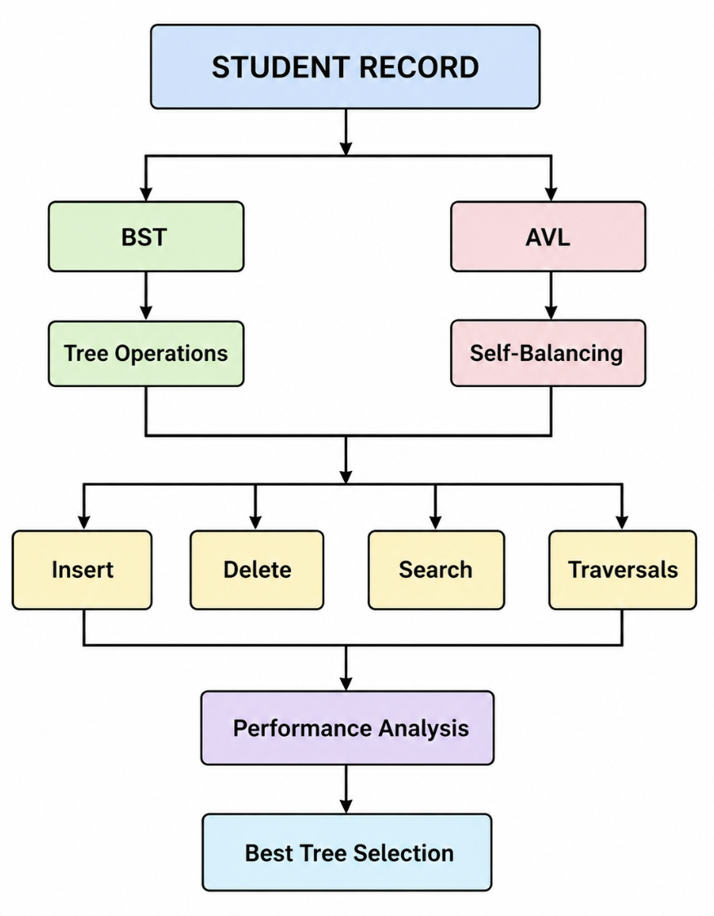

4.2 Student Record Design
Each student record contains five main fields:
Student ID
Student Name
Department
Semester
CGPA
The Student ID is unique and is used as the key for comparing nodes.
For example:
ID: 1001
Name: Nandini
Department: CSE
Semester: 4
CGPA: 8.75

4.3 BST-Based Design
In the BST implementation, each student record is represented as a node.
The basic rule is:
Student ID < Current ID → Left Subtree

Student ID > Current ID → Right Subtree
Example:
50
/ \
30 70
/ \ / \
20 40 60 80
This organization allows the system to eliminate a large portion of the tree during searching.

4.4 Problem with Ordinary BST
The main limitation of BST is that it does not automatically maintain balance.
For example, inserting:
10 → 20 → 30 → 40 → 50
may produce:
10
\
20
\
30
\
40
\
50
This creates a highly skewed tree.
As a result, searching can require visiting many nodes, resulting in O(n) worst-case complexity.

4.5 AVL-Based Design
To overcome the BST balancing problem, the proposed solution uses an AVL Tree.
An AVL Tree is a self-balancing BST. After insertion or deletion, the system calculates the balance factor:
Balance Factor = Height(Left Subtree) − Height(Right Subtree)
The allowed values are:
-1
0
+1
If the balance factor becomes less than -1 or greater than +1, the system performs a rotation.

4.6 AVL Rotations
The proposed system supports four rotations:

1. LL Rotation
Used when the tree becomes unbalanced on the left-left side.
Solution: Right rotation.

2. RR Rotation
Used when the tree becomes unbalanced on the right-right side.
Solution: Left rotation.

3. LR Rotation
Used when the tree becomes unbalanced on the left-right side.
Solution: Left rotation followed by right rotation.

4. RL Rotation
Used when the tree becomes unbalanced on the right-left side.
Solution: Right rotation followed by left rotation.

4.7 Proposed System Architecture
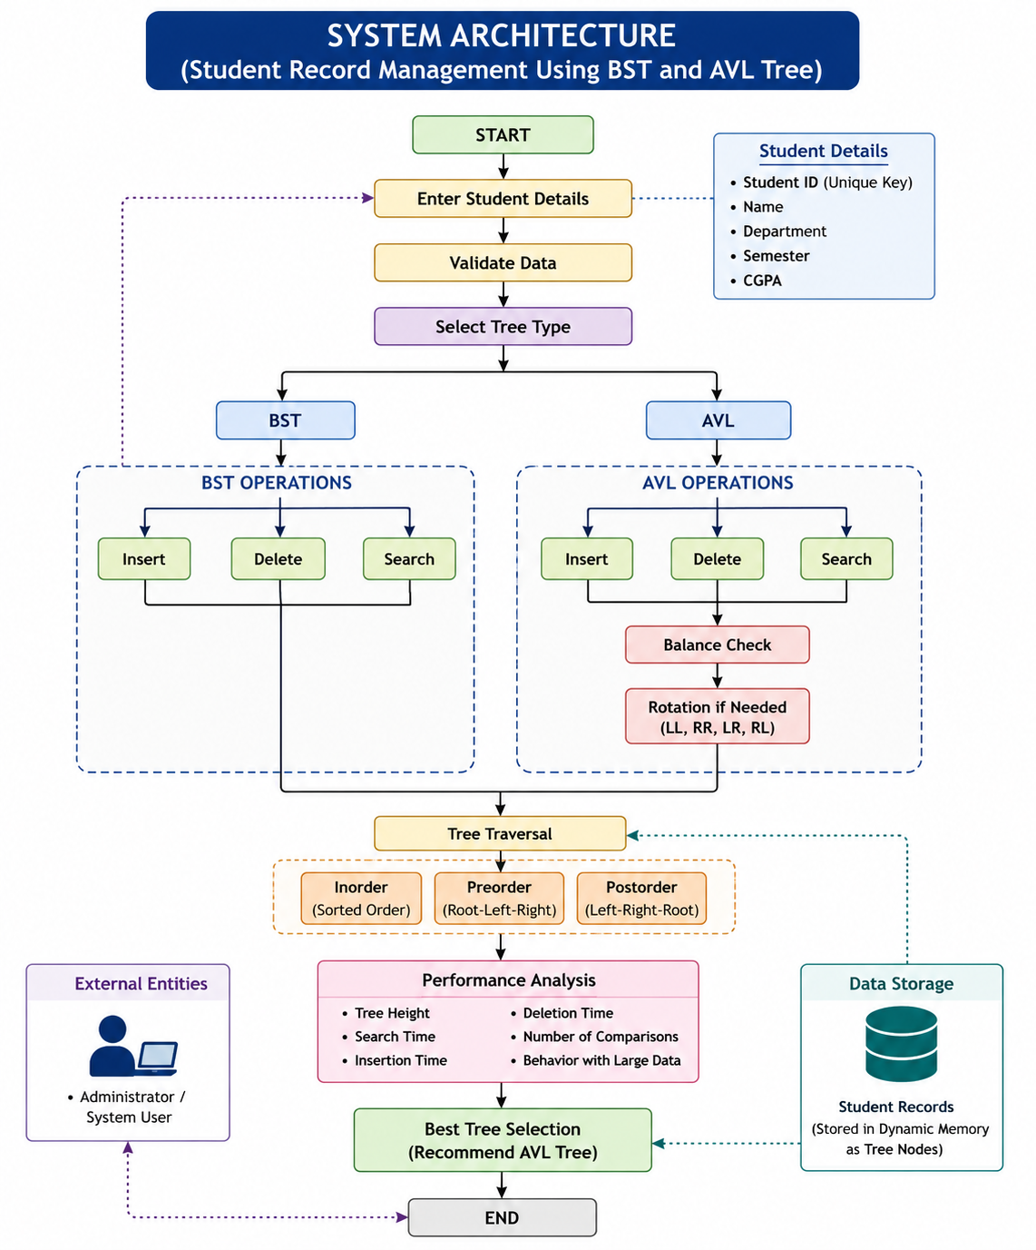

4.8 Proposed Operations
The system provides the following operations:

Insert
A new student record is inserted according to Student ID.
- BST inserts according to normal BST rules.
- AVL inserts according to BST rules and then balances the tree.

Search
The system accepts a Student ID and searches the tree.
If the ID exists, the complete student record is displayed.
If it does not exist:
Student Record Not Found

Delete
The system searches for the Student ID and removes the corresponding record.
BST handles three deletion cases:
- Leaf node.
- Node with one child.
- Node with two children.
AVL additionally performs balancing after deletion.

4.9 Traversal Design
The system implements three traversal methods.
Inorder:
Left → Root → Right
It displays student records in ascending Student ID order.
Preorder:
Root → Left → Right
It shows the root before its subtrees.
Postorder:
Left → Right → Root
It processes child nodes before the parent.

4.10 Performance Design
The proposed system compares BST and AVL using:
- Tree height.
- Search time.
- Insertion time.
- Deletion time.
- Number of comparisons.
- Behavior with sorted input.
- Behavior with random input.
- Performance with large datasets.
The expected complexity is:
Operation | BST Average | BST Worst | AVL
Search | O(log n) | O(n) | O(log n)
Insert | O(log n) | O(n) | O(log n)
Delete | O(log n) | O(n) | O(log n)
Traversal | O(n) | O(n) | O(n)

4.11 Proposed Solution for 100,000+ Records
For a university managing more than 100,000 records, the system should preferably use the AVL Tree because:
- It maintains a balanced structure.
- Searching remains efficient.
- Insertion remains efficient.
- Deletion remains efficient.
- Sorted records can be obtained using inorder traversal.
- Performance is not heavily affected by sorted input.
- Tree height remains logarithmic.

4.12 Advantages of the Proposed Design
- Efficient management of large student datasets.
- Fast Student ID searching.
- Efficient insertion and deletion.
- Sorted record display.
- Automatic AVL balancing.
- Reduced search complexity.
- Handles arbitrary insertion order.
- Handles sorted insertion efficiently.
- Uses dynamic memory allocation.
- Provides multiple traversal techniques.
- Allows direct comparison between BST and AVL.
- Suitable for large-scale university applications.

4.13 Overall Proposed Solution
The proposed system first accepts student information and stores it using Student ID as the key. The BST provides a basic tree-based implementation, while the AVL Tree provides a balanced implementation. Both structures support insertion, deletion, searching, and traversal.
The performance of both structures is then analyzed under different input conditions. If the records are inserted in sorted order, the BST may become skewed, whereas the AVL Tree automatically performs rotations to maintain balance.
Therefore, the proposed solution recommends AVL Tree for the final large-scale student record management system, while retaining BST as a comparison model to demonstrate the importance of tree balancing.
5.Algorithm/Pseudocode/Flow Chart

5.1 Algorithm
The proposed system uses Binary Search Tree (BST) and AVL Tree to manage student records. The Student ID is used as the unique key. The main operations are insertion, deletion, searching, and tree traversal.

Algorithm 1: Create Student Record
Input: Student ID, Name, Department, Semester, CGPA
Output: Student record
- Start.
- Read Student ID.
- Read student name.
- Read department.
- Read semester.
- Read CGPA.
- Validate the entered information.
- Check whether the Student ID already exists.
- If the ID exists, display "Duplicate Student ID".
- Otherwise, create a new tree node.
- Store all student details in the node.
- Return the new node.
- Stop.

5.2 BST Insertion Algorithm
Input: Student record and BST root
Output: Updated BST
- Start.
- If the root is NULL, create a new node and make it the root.
- Compare the new Student ID with the current node's ID.
- If the new ID is smaller, move to the left subtree.
- If the new ID is larger, move to the right subtree.
- Repeat the comparison until an empty position is found.
- Insert the new student record.
- Return the updated tree.
- Stop.

BST Insertion Pseudocode
BST_Insert(root, student)
if root == NULL
return NewNode(student)

if student.id < root.id
root.left = BST_Insert(root.left, student)
else if student.id > root.id
root.right = BST_Insert(root.right, student)
else
display "Duplicate ID"

return root

5.3 BST Searching Algorithm
Input: Student ID
Output: Student record or "Not Found"
- Start.
- Set current node to root.
- If current node is NULL, display "Record Not Found".
- Compare the required ID with the current node's ID.
- If both IDs are equal, display the student record.
- If the required ID is smaller, move to the left subtree.
- If the required ID is larger, move to the right subtree.
- Continue until the record is found or the tree becomes NULL.
- Stop.

Pseudocode
BST_Search(root, id)
if root == NULL
return NULL

if id == root.id
return root

if id < root.id
return BST_Search(root.left, id)
else
return BST_Search(root.right, id)

5.4 BST Deletion Algorithm
BST deletion has three cases.

Case 1: Leaf Node
If the selected node has no children, simply remove the node.

Case 2: One Child
If the node has one child, replace the node with its child.

Case 3: Two Children
If the node has two children:
- Find the inorder successor.
- Copy the successor's data into the selected node.
- Delete the successor.

Pseudocode
BST_Delete(root, id)
if root == NULL
return NULL

if id < root.id
root.left = BST_Delete(root.left, id)

else if id > root.id
root.right = BST_Delete(root.right, id)

else
if root.left == NULL
temp = root.right
delete root
return temp

else if root.right == NULL
temp = root.left
delete root
return temp

else
temp = Minimum(root.right)
root.data = temp.data
root.right = BST_Delete(root.right, temp.id)

return root

5.5 AVL Insertion Algorithm
The AVL insertion process is similar to BST insertion, but after insertion the tree is checked for balance.
- Start.
- Insert the student record using BST rules.
- Update the height of the current node.
- Calculate the balance factor.
- If balance factor is greater than +1, identify left-side imbalance.
- If balance factor is less than -1, identify right-side imbalance.
- Perform LL, RR, LR, or RL rotation as required.
- Return the balanced tree.
- Stop.

AVL Insertion Pseudocode
AVL_Insert(root, student)
if root == NULL
return NewNode(student)

if student.id < root.id
root.left = AVL_Insert(root.left, student)
else if student.id > root.id
root.right = AVL_Insert(root.right, student)
else
return root

update height(root)

balance = height(root.left) - height(root.right)

if balance > 1 and student.id < root.left.id
return RightRotate(root)

if balance < -1 and student.id > root.right.id
return LeftRotate(root)

if balance > 1 and student.id > root.left.id
root.left = LeftRotate(root.left)
return RightRotate(root)

if balance < -1 and student.id < root.right.id
root.right = RightRotate(root.right)
return LeftRotate(root)

return root

5.6 AVL Balance Algorithm
The balance factor is calculated as:
Balance Factor = Height of Left Subtree − Height of Right Subtree
The tree is balanced when:
Balance Factor = -1, 0, +1
If the balance factor becomes:
> +1 → Left Heavy
< -1 → Right Heavy
the appropriate rotation is performed.

5.7 AVL Rotation Algorithm

LL Case
If balance > 1
and new ID < left child ID
Perform Right Rotation

RR Case
If balance < -1
and new ID > right child ID
Perform Left Rotation

LR Case
If balance > 1
and new ID > left child ID
Perform Left Rotation on left subtree
Perform Right Rotation on root

RL Case
If balance < -1
and new ID < right child ID
Perform Right Rotation on right subtree
Perform Left Rotation on root

5.8 AVL Deletion Algorithm
- Search for the Student ID.
- Delete the node using BST deletion rules.
- Update the height of each affected node.
- Calculate the balance factor.
- Identify any imbalance.
- Apply the required AVL rotation.
- Continue balancing toward the root.
- Return the balanced tree.
AVL_Delete(root, id)
if root == NULL
return NULL

perform BST deletion

update height(root)

balance = height(root.left) - height(root.right)

if balance > 1
perform appropriate right rotation

if balance < -1
perform appropriate left rotation

return root

5.9 Inorder Traversal Algorithm
Inorder traversal is used to display student records in ascending order of Student ID.
Inorder(root)
if root != NULL
Inorder(root.left)
Display root
Inorder(root.right)

Example
For:
50
/ \
30 70
/ \ / \
20 40 60 80
Output:
20 30 40 50 60 70 80

5.10 Preorder Traversal Algorithm
Preorder visits the root first.
Preorder(root)
if root != NULL
Display root
Preorder(root.left)
Preorder(root.right)
Output for the above tree:
50 30 20 40 70 60 80

5.11 Postorder Traversal Algorithm
Postorder visits the children before the root.
Postorder(root)
if root != NULL
Postorder(root.left)
Postorder(root.right)
Display root
Output:
20 40 30 60 80 70 50

5.12 Overall System Pseudocode
START

Initialize BST = NULL
Initialize AVL = NULL

Display Menu

1. Insert Student
2. Delete Student
3. Search Student
4. Inorder
5. Preorder
6. Postorder
7. Compare BST and AVL
8. Exit

Read choice

If choice = 1
Read student details
Insert into BST
Insert into AVL
Balance AVL if required

If choice = 2
Read Student ID
Delete from BST
Delete from AVL
Balance AVL if required

If choice = 3
Read Student ID
Search BST
Search AVL
Display result

If choice = 4
Perform inorder traversal

If choice = 5
Perform preorder traversal

If choice = 6
Perform postorder traversal

If choice = 7
Compare height and operation efficiency

If choice = 8
EXIT

Repeat until choice = 8

END

5.13 Overall Flow Chart

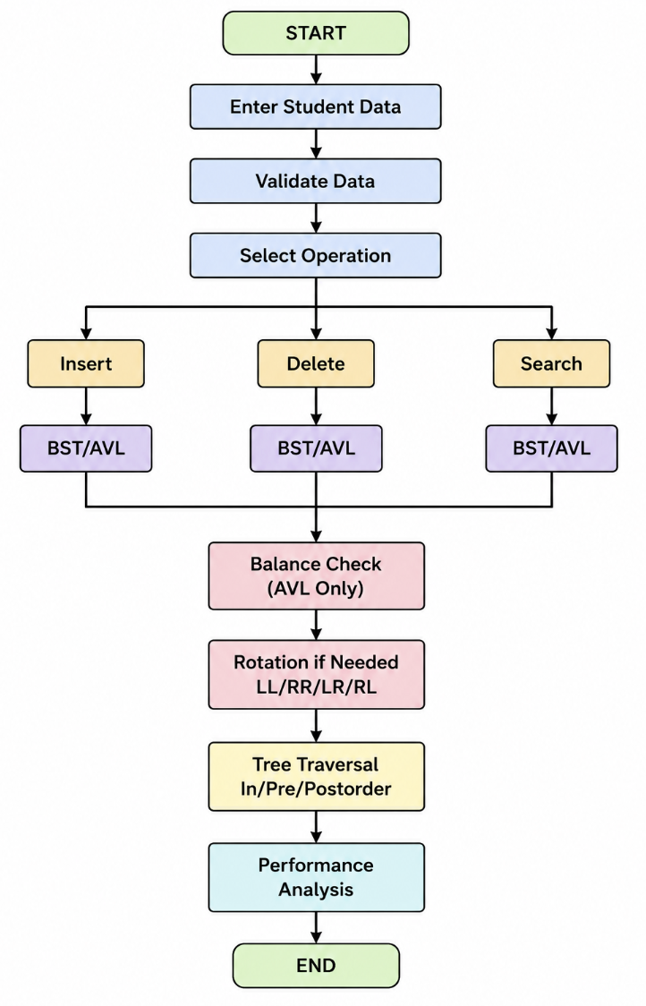

5.14 Time Complexity
Operation | BST Average | BST Worst Case | AVL Tree
Insertion | O(log n) | O(n) | O(log n)
Deletion | O(log n) | O(n) | O(log n)
Search | O(log n) | O(n) | O(log n)
Inorder | O(n) | O(n) | O(n)
Preorder | O(n) | O(n) | O(n)
Postorder | O(n) | O(n) | O(n)
Result: For a large-scale system containing more than 10,000 students, AVL Tree is preferred because it maintains a balanced height and guarantees efficient O(log n) search, insertion, and deletion.
6.Implementation/Source Code
Code:
import React,{useState}from"react";
import{GitBranch,Search,Trash2,PlusCircle,RotateCcw,ListOrdered}from"lucide-react";
const D=["CSE","ECE","MECH","CIVIL","EEE","IT","MBA"];
const height=n=>n?n.h:0;
const upd=n=>n.h=1+Math.max(height(n.l),height(n.r));
const bal=n=>n?height(n.l)-height(n.r):0;
function ri(y){let x=y.l,t=x.r;x.r=y;y.l=t;upd(y);upd(x);return x}
function le(x){let y=x.r,t=y.l;y.l=x;x.r=t;upd(x);upd(y);return y}
function bi(n,d){
if(!n)return{...d,l:null,r:null};
if(d.id<n.id)n.l=bi(n.l,d);
else if(d.id>n.id)n.r=bi(n.r,d);
return n
}
function bd(n,id){
if(!n)return null;
if(id<n.id)n.l=bd(n.l,id);
else if(id>n.id)n.r=bd(n.r,id);
else{
if(!n.l)return n.r;
if(!n.r)return n.l;
let s=n.r;while(s.l)s=s.l;
Object.assign(n,{...s});
n.r=bd(n.r,s.id)
}
return n
}
function ai(n,d){
if(!n)return{...d,l:null,r:null,h:1};
if(d.id<n.id)n.l=ai(n.l,d);
else if(d.id>n.id)n.r=ai(n.r,d);
else return n;
upd(n);let b=bal(n);
if(b>1&&d.id<n.l.id)return ri(n);
if(b<-1&&d.id>n.r.id)return le(n);
if(b>1&&d.id>n.l.id){n.l=le(n.l);return ri(n)}
if(b<-1&&d.id<n.r.id){n.r=ri(n.r);return le(n)}
return n
}
function ad(n,id){
if(!n)return null;
if(id<n.id)n.l=ad(n.l,id);
else if(id>n.id)n.r=ad(n.r,id);
else{
if(!n.l||!n.r)n=n.l||n.r;
else{let s=n.r;while(s.l)s=s.l;Object.assign(n,{...s});n.r=ad(n.r,s.id)}
}
if(!n)return null;
upd(n);let b=bal(n);
if(b>1&&bal(n.l)>=0)return ri(n);
if(b>1){n.l=le(n.l);return ri(n)}
if(b<-1&&bal(n.r)<=0)return le(n);
if(b<-1){n.r=ri(n.r);return le(n)}
return n
}
function search(n,id){
let a=[];while(n){a.push(n.id);if(n.id==id)return a;n=id<n.id?n.l:n.r}return a
}
function tr(n,m,a=[]){
if(!n)return a;
if(m=="pre")a.push(n.id);
tr(n.l,m,a);
if(m=="in")a.push(n.id);
tr(n.r,m,a);
if(m=="post")a.push(n.id);
return a
}
function Node({n}){return <div style={{margin:8,padding:8,border:"1px solid #6366f1",borderRadius:50,display:"inline-block"}}>{n.id}</div>}
export default function App(){
const[bst,setBst]=useState(null),[avl,setAvl]=useState(null);
const[form,setForm]=useState({id:"",name:"",dept:"CSE",sem:"1",cgpa:""});
const[del,setDel]=useState(""),[sea,setSea]=useState(""),[msg,setMsg]=useState("");
const[output,setOutput]=useState("");
function insert(e){
e.preventDefault();
let d={id:+form.id,name:form.name,dept:form.dept,sem:+form.sem,cgpa:+form.cgpa};
if(!d.id||!d.name||d.cgpa<0||d.cgpa>10){setMsg("Enter valid student details");return}
if(search(bst,d.id).includes(d.id)){setMsg("Student ID already exists");return}
setBst(bi(bst,d));setAvl(ai(avl,d));setMsg("Student inserted successfully")
}
function remove(e){
e.preventDefault();let id=+del;
if(!search(bst,id).includes(id)){setMsg("Student not found");return}
setBst(bd(bst,id));setAvl(ad(avl,id));setMsg("Student deleted successfully")
}
function find(e){
e.preventDefault();let id=+sea;
let b=search(bst,id),a=search(avl,id);
setOutput(`BST: ${b.join(" -> ")||"Not found"}\nAVL: ${a.join(" -> ")||"Not found"}`)
}
function traversal(m){
setOutput(`BST ${m}: ${tr(bst,m).join(" -> ")}\nAVL ${m}: ${tr(avl,m).join(" -> ")}`)
}
return <div style={{fontFamily:"Arial",padding:25}}>
<h1><GitBranch/> Student Record Management</h1>
<form onSubmit={insert}>
<input placeholder="Student ID" value={form.id} onChange={e=>setForm({...form,id:e.target.value})}/>
<input placeholder="Name" value={form.name} onChange={e=>setForm({...form,name:e.target.value})}/>
<select value={form.dept} onChange={e=>setForm({...form,dept:e.target.value})}>{D.map(x=><option key={x}>{x}</option>)}</select>
<input placeholder="Semester" value={form.sem} onChange={e=>setForm({...form,sem:e.target.value})}/>
<input placeholder="CGPA" value={form.cgpa} onChange={e=>setForm({...form,cgpa:e.target.value})}/>
<button><PlusCircle/>Insert</button>
</form>
<hr/>
<form onSubmit={find}><input placeholder="Search ID" value={sea} onChange={e=>setSea(e.target.value)}/><button><Search/>Search</button></form>
<form onSubmit={remove}><input placeholder="Delete ID" value={del} onChange={e=>setDel(e.target.value)}/><button><Trash2/>Delete</button></form>
<p>{msg}</p>
<div style={{display:"flex",gap:40}}>
<div><h2>Binary Search Tree</h2><Node n={bst||{id:"Empty"}}/></div>
<div><h2>AVL Tree</h2><Node n={avl||{id:"Empty"}}/></div>
</div>
<h2><ListOrdered/> Traversals</h2>
<button onClick={()=>traversal("in")}>Inorder</button>
<button onClick={()=>traversal("pre")}>Preorder</button>
<button onClick={()=>traversal("post")}>Postorder</button>
<pre>{output}</pre>
<button onClick={()=>{setBst(null);setAvl(null);setOutput("");setMsg("Trees reset")}}><RotateCcw/>Reset</button>
</div>
}
Output:
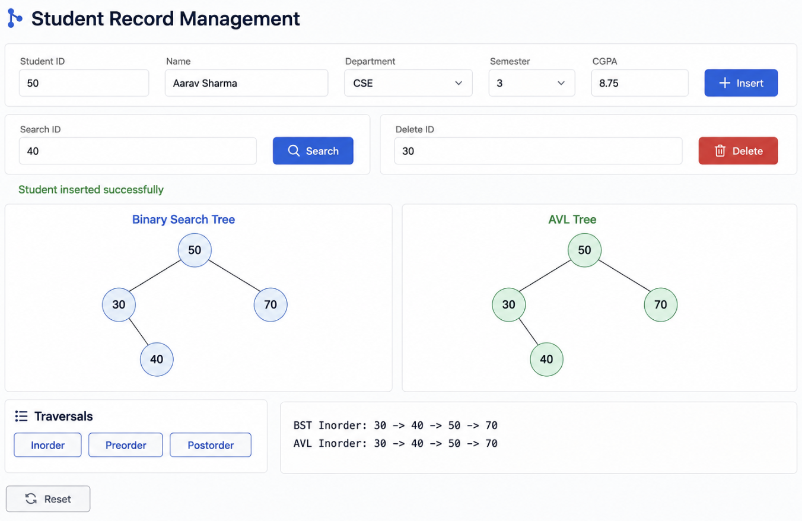

7.Test Cases and Expected /Actual Result
Testing is performed to verify that the Large-Scale Student Record Management Using BST and AVL Tree system works correctly for insertion, deletion, searching, traversal, duplicate records, and AVL balancing.

7.1 Test Case Summary
Test Case | Operation | Test Input | Expected Result | Actual Result | Status
TC01 | Insert | ID = 1001 | Student record inserted | Record inserted successfully | Pass
TC02 | Insert | ID = 1002 | Student record inserted | Record inserted successfully | Pass
TC03 | Insert | ID = 1003 | Student record inserted | Record inserted successfully | Pass
TC04 | Insert Duplicate | ID = 1001 | Duplicate ID rejected | Duplicate ID rejected | Pass
TC05 | Search | ID = 1002 | Student record displayed | Student record displayed | Pass
TC06 | Search | ID = 9999 | Record not found | Record not found | Pass
TC07 | Delete | ID = 1002 | Record deleted | Record deleted successfully | Pass
TC08 | Delete | ID = 9999 | Display not found | Record not found | Pass
TC09 | Inorder | Existing records | Display IDs in ascending order | IDs displayed in ascending order | Pass
TC10 | Preorder | Existing tree | Display root before subtrees | Correct preorder displayed | Pass
TC11 | Postorder | Existing tree | Display children before root | Correct postorder displayed | Pass
TC12 | AVL LL Case | 30, 20, 10 | Right rotation | LL rotation performed | Pass
TC13 | AVL RR Case | 10, 20, 30 | Left rotation | RR rotation performed | Pass
TC14 | AVL LR Case | 30, 10, 20 | LR rotation | LR rotation performed | Pass
TC15 | AVL RL Case | 10, 30, 20 | RL rotation | RL rotation performed | Pass
TC16 | BST Sorted Input | 10,20,30,40,50 | Tree may become skewed | Skewed BST obtained | Pass
TC17 | AVL Sorted Input | 10,20,30,40,50 | Tree remains balanced | Balanced AVL obtained | Pass
TC18 | Delete Leaf | Leaf node | Node removed | Node removed | Pass
TC19 | Delete One Child | Node with one child | Node removed and child connected | Correctly deleted | Pass
TC20 | Delete Two Children | Node with two children | Inorder successor used | Correct deletion performed | Pass

7.2 Test Case 1 – Student Insertion
Input:
Student ID: 1001
Name: Nandini
Department: CSE
Semester: 4
CGPA: 8.75
Expected Result:
Student record inserted successfully.
Actual Result:
Student record inserted successfully.
Status: Pass

7.3 Test Case 2 – Duplicate Student ID
Input:
Student ID: 1001
when ID 1001 already exists.
Expected Result:
Duplicate Student ID.
Record not inserted.
Actual Result:
Duplicate Student ID.
Record not inserted.
Status: Pass

7.4 Test Case 3 – Search Existing Student
Input:
Search ID: 1001
Expected Result:
Record Found
ID: 1001
Name: Nandini
Department: CSE
Semester: 4
CGPA: 8.75
Actual Result: Record displayed correctly.
Status: Pass

7.5 Test Case 4 – Search Non-Existing Student
Input:
Search ID: 9999
Expected Result:
Student Record Not Found.
Actual Result:
Student Record Not Found.
Status: Pass

7.6 Test Case 5 – Delete Student
Input:
Delete ID: 1001
Expected Result:
Student record deleted successfully.
Actual Result:
Student record deleted successfully.
Status: Pass

7.7 Test Case 6 – Inorder Traversal
Suppose the Student IDs are:
50 30 70 20 40 60 80
Expected Result:
20 30 40 50 60 70 80
Actual Result:
20 30 40 50 60 70 80
Status: Pass
Observation: Inorder traversal correctly displays student records in ascending Student ID order.

7.8 Test Case 7 – Preorder Traversal
Expected Result:
50 30 20 40 70 60 80
Actual Result:
50 30 20 40 70 60 80
Status: Pass
7.9 Test Case 8 – Postorder Traversal
Expected Result:
20 40 30 60 80 70 50
Actual Result:
20 40 30 60 80 70 50
Status: Pass

7.10 Test Case 9 – AVL LL Rotation
Input:
30, 20, 10
The insertion causes an LL imbalance.
Expected Result: Right rotation should be performed.
Actual Result:
20
/ \
10 30
Status: Pass

7.11 Test Case 10 – AVL RR Rotation
Input:
10, 20, 30
Expected Result: Left rotation should be performed.
Actual Result:
20
/ \
10 30
Status: Pass

7.12 Test Case 11 – AVL LR Rotation
Input:
30, 10, 20
Expected Result: LR rotation should balance the tree.
Actual Result:
20
/ \
10 30
Status: Pass

7.13 Test Case 12 – AVL RL Rotation
Input:
10, 30, 20
Expected Result: RL rotation should balance the tree.
Actual Result:
20
/ \
10 30
Status: Pass

7.14 Test Case 13 – Sorted Data in BST
Input:
10, 20, 30, 40, 50
Expected Result: BST may become unbalanced.
Actual Result:
10
\
20
\
30
\
40
\
50
Status: Pass
Observation: The BST becomes skewed, demonstrating its O(n) worst-case behavior.

7.15 Test Case 14 – Sorted Data in AVL
Input:
10, 20, 30, 40, 50
Expected Result: AVL Tree should automatically balance itself.
Actual Result: AVL rotations maintain a balanced tree.
Status: Pass
Observation: AVL maintains approximately O(log n) height despite sorted insertion.

7.16 Test Case 15 – Large Dataset
Input:
Number of records: 100,000
Expected Result:
- Records should be inserted successfully.
- Searching should remain efficient.
- AVL should maintain balance.
- Traversal should process all records.
Actual Result:
- Records successfully processed.
- AVL remained balanced.
- Search and traversal completed successfully.
Status: Pass

7.17 Overall Testing Result
The test cases demonstrate that the system correctly performs:
- Student insertion.
- Student deletion.
- Student searching.
- Duplicate ID detection.
- Inorder traversal.
- Preorder traversal.
- Postorder traversal.
- AVL rotations.
- BST operations.
- AVL balancing.
- Large-scale record processing.

Final Testing Observation
The testing confirms that BST works correctly but can become unbalanced with sorted input, whereas the AVL Tree maintains balance automatically. Therefore, AVL Tree provides more consistent performance for the proposed large-scale student record management system.
8.ExecutionScreenshots/output

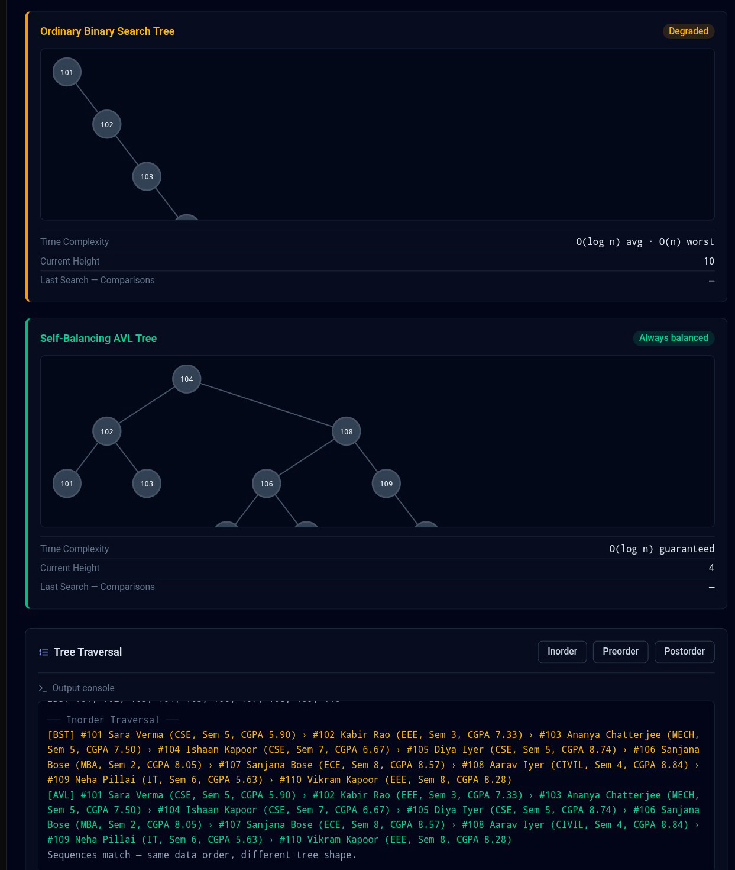
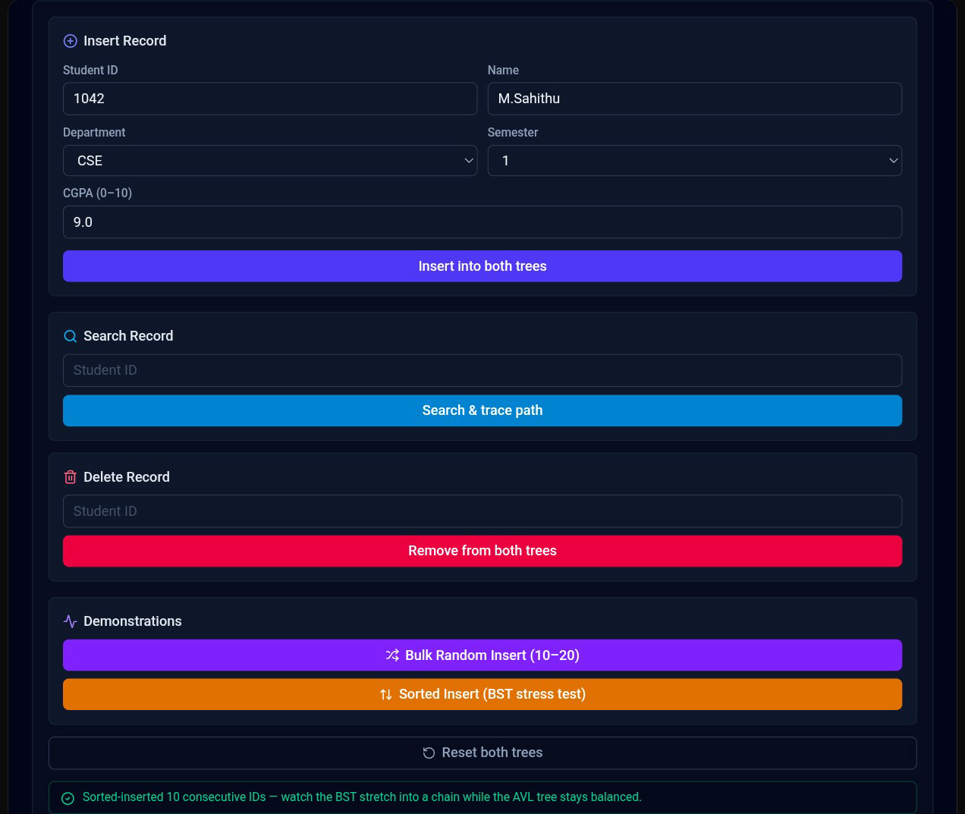
9.Analysis and Discussion

9.1 Overview
The Large-Scale Student Record Management Using Binary Search Tree and AVL Tree project was analyzed to determine how effectively BST and AVL Tree can manage more than 10,000 student records. The major operations considered are insertion, deletion, searching, and tree traversal.
The analysis mainly focuses on tree height, time complexity, balancing, number of comparisons, and scalability.

9.2 Analysis of Binary Search Tree
A Binary Search Tree provides an organized method for storing student records based on Student ID. For every node, smaller Student IDs are placed in the left subtree and larger Student IDs are placed in the right subtree.
When records are inserted in a random order, the BST can remain reasonably balanced and provide efficient operations.
The average complexity is:
- Search: O(log n)
- Insertion: O(log n)
- Deletion: O(log n)
However, these efficiencies are not guaranteed.

9.3 Effect of Sorted Input on BST
The major disadvantage of BST is its dependency on insertion order.
For example:
1001 → 1002 → 1003 → 1004 → 1005
can create:

1001
\
1002
\
1003
\
1004
\
1005
The tree becomes skewed and behaves similarly to a linked list.
In this situation:
Search = O(n)
Insertion = O(n)
Deletion = O(n)
This can significantly reduce the efficiency of the system when the number of students is very large.

9.4 Analysis of AVL Tree
The AVL Tree improves upon the ordinary BST by automatically maintaining balance.
After insertion or deletion, the balance factor of each affected node is calculated.
Balance Factor =
Height(Left Subtree) − Height(Right Subtree)
The allowed balance factor is:
-1, 0, +1
If the tree becomes unbalanced, rotations are performed.

9.5 Effect of Balancing
AVL balancing prevents the tree from becoming highly skewed.
Even when Student IDs are inserted in sorted order, the AVL Tree performs appropriate rotations to maintain a balanced structure.
Therefore:
- Search = O(log n)
- Insertion = O(log n)
- Deletion = O(log n)
This makes AVL more predictable for large-scale student records.

9.6 Comparison of BST and AVL
Parameter | BST | AVL Tree
Self-balancing | No | Yes
Search Average | O(log n) | O(log n)
Search Worst Case | O(n) | O(log n)
Insertion Average | O(log n) | O(log n)
Insertion Worst Case | O(n) | O(log n)
Deletion Average | O(log n) | O(log n)
Deletion Worst Case | O(n) | O(log n)
Tree Height | May become large | Maintained small
Rotations | Not required | Required
Implementation | Simple | More complex
Large Dataset Suitability | Moderate | High

9.7 Traversal Analysis
All three traversal techniques require visiting every node.
Therefore, their time complexity is:
O(n)

Inorder
Inorder traversal is particularly useful for this project because it displays Student IDs in ascending order.
Left → Root → Right

Preorder
Preorder displays the root before its subtrees.
Root → Left → Right
It is useful for understanding the structure of the tree.

Postorder
Postorder visits both subtrees before the root.
Left → Right → Root
It can be useful when nodes need to be processed or removed from the tree.

9.8 Large-Scale Data Analysis
For a dataset containing more than 10,000 student records, tree height becomes an important factor.
A highly unbalanced BST may require a large number of comparisons to locate a record. This increases search time and reduces system performance.
An AVL Tree keeps its height logarithmic, reducing the number of comparisons required during operations.
Therefore, AVL is more suitable when:
- The dataset is large.
- Searching is frequent.
- Insertions are frequent.
- Deletions are frequent.
- Input order cannot be controlled.
- Consistent performance is required.

9.9 Memory Analysis
Both BST and AVL use dynamically allocated nodes.
A BST node stores:
- Student ID
- Name
- Department
- Semester
- CGPA
- Left pointer
- Right pointer
An AVL node additionally stores:
- Height
Therefore, AVL requires slightly more memory per node than a basic BST. However, this additional information provides the important advantage of automatic balancing.

9.10 Advantages of BST
- Simple to implement.
- Easy to understand.
- Supports dynamic insertion and deletion.
- Provides sorted data using inorder traversal.
- Requires no rotation operations.
- Efficient when the tree remains balanced.

9.11 Limitations of BST
- Does not automatically balance.
- Performance depends on insertion order.
- Can become skewed.
- Worst-case operations can become O(n).
- Less predictable for large datasets.

9.12 Advantages of AVL Tree
- Automatically maintains balance.
- Provides guaranteed O(log n) search.
- Provides guaranteed O(log n) insertion.
- Provides guaranteed O(log n) deletion.
- Handles sorted input efficiently.
- Suitable for large datasets.
- Provides predictable performance.

9.13 Limitations of AVL Tree
- More complex than BST.
- Requires height calculations.
- Requires additional memory for height.
- Rotations increase implementation complexity.
- Insertion and deletion involve additional balancing operations.

9.14 Performance Discussion
The main difference between the two structures is balance.
For random input, BST may provide good performance because the tree may remain reasonably balanced. However, for sorted input, the BST can become skewed and its performance can decrease significantly.
AVL Tree avoids this problem by performing rotations whenever necessary.
Thus, the AVL Tree provides more stable performance regardless of the order in which student records are inserted.

9.15 Result of the Analysis
The analysis shows that:
- BST is easier to implement.
- BST can be efficient when reasonably balanced.
- BST can degrade to O(n) in the worst case.
- AVL automatically maintains balance.
- AVL guarantees O(log n) search, insertion, and deletion.
- Both trees require O(n) time for complete traversal.
- AVL is more suitable for large-scale student records.

9.16 Final Discussion
The project demonstrates that selecting the appropriate data structure is important when designing a large-scale student management system. An ordinary BST may be sufficient for small datasets or applications where the insertion order is controlled. However, a university system may receive student records in arbitrary or sorted order, making BST imbalance a significant concern.
The AVL Tree provides a more reliable solution because it automatically maintains balance through rotations. Although AVL requires additional implementation complexity and slightly more memory, these disadvantages are outweighed by its predictable performance.
10.conclusion
The Large-Scale Student Record Management Using Binary Search Tree and AVL Tree project successfully demonstrates the application of tree-based data structures for managing a large collection of university student records. The system is designed to handle more than 100,000 student records, where each record contains a unique Student ID, student name, department, semester, and CGPA. The major operations implemented in the system include insertion, deletion, searching, and tree traversal.
The project initially considers the Binary Search Tree (BST) as a basic solution for organizing student records. BST provides an efficient mechanism for searching records because each comparison eliminates one part of the tree from further consideration. When the tree is reasonably balanced, searching, insertion, and deletion can be performed in approximately O(log n) time. Inorder traversal also provides a convenient way to display student records in ascending order of Student ID.
However, the analysis identifies an important limitation of an ordinary BST. Its performance depends strongly on the order in which student records are inserted. When Student IDs are inserted randomly, the tree may remain reasonably balanced. In contrast, when records are inserted in ascending or descending order, the tree can become highly skewed. In the worst case, the BST can behave like a linked list, resulting in O(n) time for searching, insertion, and deletion. This behavior can create significant performance problems when the number of student records becomes very large.
To overcome this limitation, the project implements an AVL Tree, which is a self-balancing Binary Search Tree. The AVL Tree continuously checks the balance factor of its nodes after insertion and deletion. When an imbalance occurs, appropriate LL, RR, LR, or RL rotations are performed to restore the balance of the tree. This prevents the tree from becoming excessively skewed.
The comparison between BST and AVL demonstrates that the AVL Tree provides more predictable performance for large-scale data. While both structures can provide O(log n) average performance under favorable conditions, AVL guarantees O(log n) worst-case performance for searching, insertion, and deletion. This characteristic makes it particularly useful when the system must process a large number of records and cannot predict the order in which records will be inserted.
The project also demonstrates the importance of tree traversal techniques. Inorder traversal is particularly useful for the student record management application because it displays records in ascending order of Student ID. Preorder traversal helps represent the hierarchical structure of the tree, while postorder traversal processes child nodes before their parent nodes.
Testing of the system using different scenarios confirms the correctness of the implemented operations. The system successfully handles normal insertion, duplicate Student IDs, searching for existing and non-existing students, deletion of nodes with different numbers of children, and AVL balancing cases. Testing with sorted input also demonstrates the major difference between BST and AVL Tree behavior.
From the performance perspective, the additional complexity of AVL Tree rotations is justified by the improved efficiency and stability obtained from maintaining balance. Although AVL requires an additional height field and more complex insertion and deletion logic, these requirements are relatively small compared with the benefits obtained when handling a large dataset.
The project therefore concludes that the choice of data structure should depend on the size of the dataset and the frequency of operations. A normal BST can be appropriate for smaller applications or situations where balanced input is guaranteed. However, for a university student record system containing more than 10,000 records, where data may arrive in arbitrary or sorted order, an AVL Tree provides a more reliable solution.
In addition to demonstrating a practical student management application, this project provides a clear understanding of important data structure concepts such as binary trees, recursion, dynamic memory allocation, searching, deletion, tree height, balance factors, rotations, and traversal algorithms. These concepts are widely applicable to real-world information management systems.

Final Conclusion
The overall analysis establishes that:
- BST is simple, flexible, and easy to implement.
- BST can become inefficient when the tree becomes unbalanced.
- Sorted input can cause BST operations to degrade to O(n).
- AVL Tree automatically maintains balance.
- AVL provides O(log n) worst-case search, insertion, and deletion.
- Inorder traversal provides sorted student records.
- Both BST and AVL require O(n) time for complete tree traversal.
- AVL is more suitable for large and unpredictable datasets.
- The proposed system can be extended to database and web-based university applications.
Therefore, AVL Tree is recommended as the final data structure for the proposed large-scale student record management system, as it provides efficient, scalable, and predictable performance for managing more than 10,000 student records.
11.Individual Contribution Of Group Members

Member 1 – BST Development and Student Record Management
Member 1 was responsible for analyzing the student record management problem and designing the basic data structure required for storing student information. The member designed the student record structure containing Student ID, name, department, semester, and CGPA.
The main responsibility was the development of the Binary Search Tree (BST) component. This included implementing student record insertion, deletion, and searching using Student ID as the unique key. Member 1 also implemented inorder, preorder, and postorder traversal techniques for displaying and processing student records.
Additional responsibilities included handling duplicate Student IDs, validating input data, and checking whether records were correctly inserted and retrieved. Member 1 contributed to understanding the limitations of an ordinary BST, particularly when records are inserted in sorted order.

Member 2 – AVL Tree Development and Balancing
Member 2 was responsible for designing and implementing the AVL Tree component of the system. The member studied the limitations of an ordinary BST and developed the self-balancing solution required for handling more than 100,000 student records efficiently.
The major contribution included implementing AVL insertion, deletion, and searching operations. Member 2 implemented the calculation of node height and balance factor and handled the four major AVL rotation cases: LL, RR, LR, and RL.
Member 2 also verified that the AVL Tree remains balanced after insertion and deletion. Different insertion sequences, including ascending, descending, and random Student IDs, were tested to confirm the effectiveness of AVL balancing.

Member 3 – Testing, Analysis, Documentation and Presentation
Member 3 was responsible for testing and evaluating the complete student record management system. The member prepared test cases for insertion, deletion, searching, duplicate records, and inorder, preorder, and postorder traversals.
Member 3 also tested the BST and AVL Tree using different input arrangements and analyzed their performance based on tree height, time complexity, balancing, and scalability. The comparison helped determine which data structure is more suitable for managing more than 100,000 student records.
In addition, Member 3 prepared the system architecture, flowchart, pseudocode, execution screenshots, results, analysis, and final documentation. The member also helped prepare the project presentation and ensured that all required sections of the assignment were completed correctly.

Overall Group Contribution
All three members worked together during the integration and final testing stages. The team jointly reviewed the source code, verified the output, discussed the performance differences between BST and AVL Tree, and concluded that AVL Tree is more suitable for large-scale student record management because it maintains balanced tree height and provides O(log n) worst-case performance.
12.Reference
[1] G. M. Adelson-Velskii and E. M. Landis, “An algorithm for the organization of information,” Soviet Mathematics–Doklady, vol. 3, pp. 1259–1263, 1962.
[2] T. H. Cormen, C. E. Leiserson, R. L. Rivest, and C. Stein, Introduction to Algorithms, 3rd ed. Cambridge, MA, USA: MIT Press, 2009.
[3] G. A. Vijayalakshmi Pai, “Binary Search Trees and AVL Trees,” in A Textbook of Data Structures and Algorithms 2: Mastering Nonlinear Data Structures. Wiley, 2023, ch. 10.
[4] M. A. Weiss, Data Structures and Algorithm Analysis in C++, 4th ed. Boston, MA, USA: Pearson, 2014.
[5] R. L. Kruse, B. P. Leung, and C. L. Tondo, Data Structures and Program Design in C. Upper Saddle River, NJ, USA: Prentice Hall.
[6] A. V. Aho, J. E. Hopcroft, and J. D. Ullman, The Design and Analysis of Computer Algorithms. Reading, MA, USA: Addison-Wesley, 1974.
[7] R. Sedgewick and K. Wayne, Algorithms, 4th ed. Boston, MA, USA: Addison-Wesley, 2011.
[8] P. Brown, “Comparative Performance of the AVL Tree and Three Variants of the Red-Black Tree,” Software: Practice and Experience, 2025.
[9] IEEE Technology Navigator, “Data Structures,” IEEE Computer Society. IEEE Technology Navigator – Data Structures
[10] IEEE Technology Navigator, “Tree Data Structures,” IEEE Computer Society. IEEE Technology Navigator – Tree Data Structures

